LAB REPORT实验报告
Lab Title | Funtions |  |  |  | Lab No. | 03
Stud. Name | Jiang Yunxiang | Major | CST |  | Class
Student ID | 2022102330 |  | Date | 2023/3/10
Lab description/objectives:
Using this information write and test two functions
Source code:
#include <stdio.h>
int det2(int a11, int a12, int a21, int a22)
{
return a11 * a22 - a21 * a12;
}

int det3(int a11, int a12, int a13, int a21, int a22, int a23, int a31, int a32, int a33)
{
int result = 0;
result = a11 * det2(a22, a23, a32, a33) - a21 * det2(a12, a13, a32, a33) + a31 * det2(a12, a13, a22, a23);
return result;
}

int main()
{
printf("%d\n", det2(1, 2, 3, 4));
printf("%d", det3(1, 2, 3, 4, 5, 6, 7, 8, 9));

return 0;
}}
Program outputs:
（Paste the screenshot of program output here）
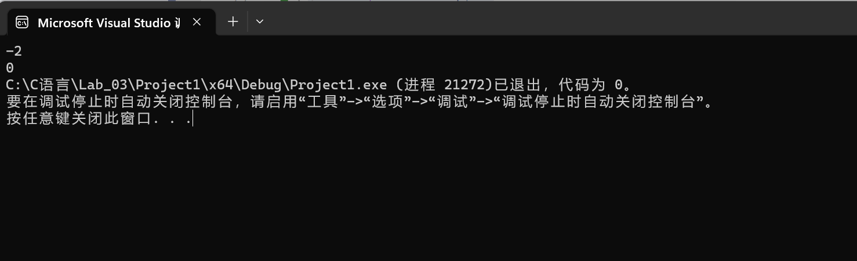
Discussion:
1．Most difficult parts
（What were the most difficult parts of your program to implement?）
How to simplify the code?
2．Bugs and/or Errors
(List all the program bugs/errors you encountered and how you corrected them.)
Nope

